**Ideation Phase**

**Define the Problem Statements**

|  |  |
| --- | --- |
| Date | 29 April 2023 |
| Team ID | NM2023TMID00069 |
| Project Name | COVID-19 Detection from Lung X-rays with Deep Learnings |
| Maximum Marks | 2 Marks |

**Problem Statement :**

There are several problems that researchers have encountered when using deep learning models for COVID-19 prediction. [One of the main challenges is the lack of large-scale datasets.](https://www.nature.com/articles/s41598-022-05532-0) [Another challenge is the lack of interpretability of deep learning models.](https://www.nature.com/articles/s41598-022-06218-3) [Additionally, the performance of deep learning models can be affected by the quality of the data.](https://pubmed.ncbi.nlm.nih.gov/32572310/) Despite these challenges, deep learning models have shown promising results in predicting COVID-19 outcomes.

**Problem Statements for Covid -19 Process:**

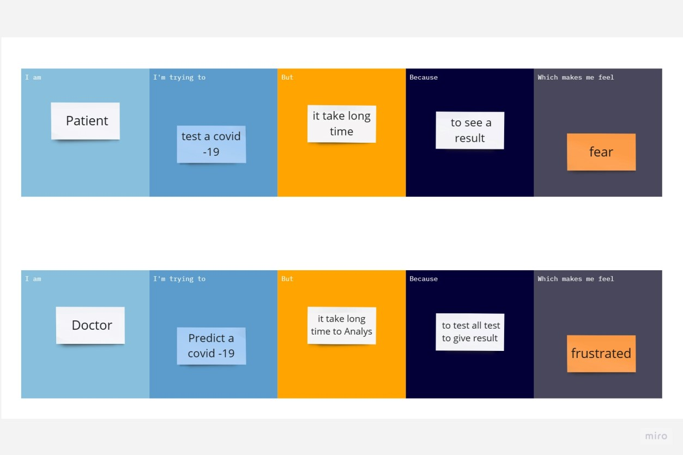

**Table for Problem Statements Covid -19 :**

|  |  |  |  |  |  |
| --- | --- | --- | --- | --- | --- |
| **Problem**  **Statement (PS)** | **I am** | **I’m trying to** | **But** | **Because** | **Which makes me feel** |
| PS-1 | Patient | test a covid-19 | It takes long time | to see a result | Fear |
| PS-2 | Doctor | Predict a covid -19 | It takes long time to analyse | To test all test to give result | Frustrated |